**Grid Compass**

**专为NASA研制——Grid Compass 1100**

　　这是世界上第一台折叠式的笔记本电脑。它采用英特尔8086 处理器、CGA 显示、1200 bit/s 调制解调器。不过它当时8000到10000美元的售价让人们望而却步（售价包含有软件和一项强制性维护协议）。当时NASA在航天飞机上用的也是这款笔记本电脑。

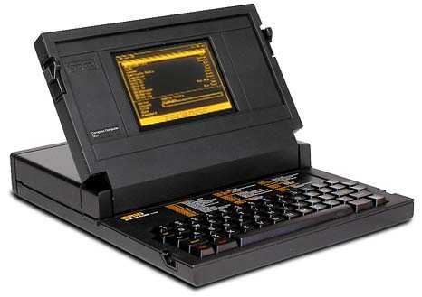

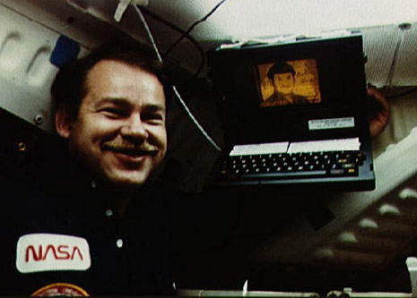

Grid Compass 1100

The Compass portable was the first computer of the Grid company; and the very first clamshell laptop (GRiD had the patent on the clamshell idea).   
  
It was an expensive portable business computer incorporating large memories (both RAM and data storage) for the time, but above all one of the first graphic amber plasma flat screen.

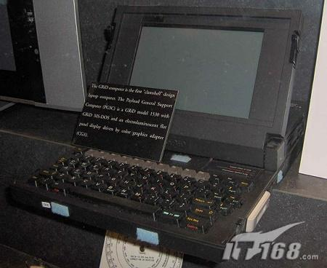

It was housed in in a matt-black finished magnesium case. Not only does this gave increased protection (and weight) that some plastic shells, it also acted as a heat-sink, so there was no cooling fan. Stangely, there was no carrying handle either. Above the keyboard was a panel displaying common command codes to refresh user's memory.   
  
Instead of a disk drive, first Compass held a 384 KB non-volatile bubble memory (like the Sharp PC-5000). Software could be loaded from a Grid server, however, user could connect an external 360 KB floppy disc or 10 MB hard disk unit. The Compass also featured a built-in modem.

目录

• [笔记本电脑](http://www.techcn.com.cn/index.php?doc-view-140401.html#1)

• [主要参数](http://www.techcn.com.cn/index.php?doc-view-140401.html#3)

• [详解](http://www.techcn.com.cn/index.php?doc-view-140401.html#5)

• [谁是第一台笔记本电脑？](http://www.techcn.com.cn/index.php?doc-view-140401.html#7)

* • [相关链接](http://www.techcn.com.cn/index.php?doc-view-140401.html#9)
* • [参考文献](http://www.techcn.com.cn/index.php?doc-view-140401.html#11)

笔记本电脑[回目录](http://www.techcn.com.cn/index.php?doc-view-140401.html" \l "section)

　　笔记本的外形和显示屏技术有很大关系，最初的笔记本只能采用CRT显示屏，因此在外形上也就可想而知。普遍的做法是，在CRT显示器前面加上一个盖，并在盖子上布置键盘，中间用线连接起来就行了。

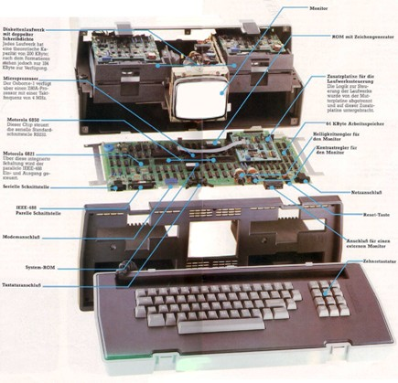

　　Osborne 1

　　以Osborne 1为例，这款Osborne Computer公司在1981年推出的机型采用CRT显示屏，CP/M操作系统，重量高达10.9千克。恐怕现在配置液晶显示屏的台式机也没有这么重，但我们不能忽略Osborne 1在提高电脑便携性上的努力。

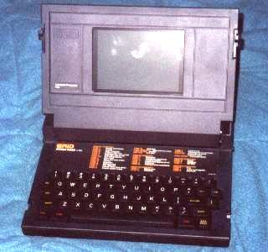　　

GriD Compass 1101

　　到1982年，William Moggridge设计的GRiD Compass 1101上市，Compass 1101的突破在于采用了等离子平板屏幕，因此在外形上呈蛤壳(Clamshell)状。我们可以看到，蛤壳状的笔记本在外形上已经很接近现在的笔记本，只是多出了一个“屁股”，因为受技术的限制，笔记本的主机配件还没办法完全布置在键盘下方。

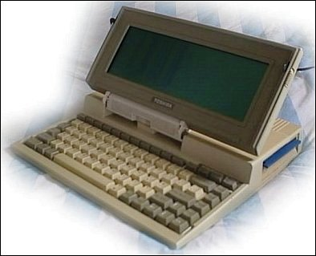

Toshiba T1000

　　在Compass 1101以后，其他一些公司还推出了不少这种蛤壳状的笔记本，东芝的T1000就是一个典型的例子。T1000是在T1100基础上发展而来的，具备硬盘和液晶显示器，而且成功地把重量控制在了3千克。从图片上我们看到，T1000的蛤壳已经和目前的笔记本电脑外形相当接近。

主要参数[回目录](http://www.techcn.com.cn/index.php?doc-view-140401.html" \l "section)

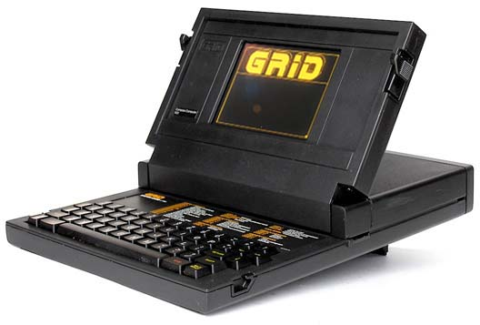

GRiD Compass 1101

|  |  |
| --- | --- |
| **Released:** | 1982 |
| **Price:** | US$8150 |
| **Weight:** | 10 lbs, 12 oz |
| **CPU:** | Intel 8086 @ 8MHz (?) |
| **RAM:** | 256K DRAM |
| **Display:** | 6-inch electroluminescent |
|  | 80 x 24 text |
|  | 320 x 240 graphics |
| **Ports:** | RS-232/422 serial |
|  | GPIB parallel port |
| **Storage:** | internal 384K bubble RAM |
|  | external floppy drive(s) |
| **OS:** | GRiD OS |

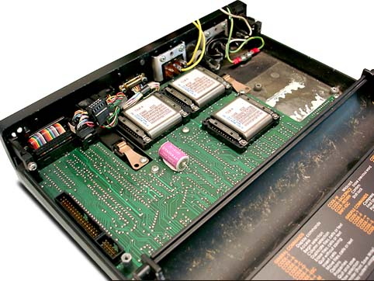

|  |  |
| --- | --- |
|  |  |

|  |  |
| --- | --- |
| **NAME** | Compass |
| **MANUFACTURER** | Grid |
| **TYPE** | Portable |
| **ORIGIN** | U.S.A. |
| **YEAR** | April 1982 |
| **BUILT IN LANGUAGE** | GRID BASIC |
| **KEYBOARD** | Full stroke 57 keys |
| **CPU** | Intel 8086 |
| **SPEED** | Unknown |
| **CO-PROCESSOR** | 8087 math coprocessor |
| **RAM** | 256 KB (up to 512 KB) |
| **VRAM** | Unknown |
| **ROM** | Unknown |
| **TEXT MODES** | 80 chars x 25 lines |
| **GRAPHIC MODES** | 320 x 240 dots |
| **COLORS** | Monochrome |
| **SOUND** | Beeper |
| **SIZE / WEIGHT** | 38 (H) x 29 (D) x 5 (H) cm / 8.5 lbs (4.3 kg) |
| **I/O PORTS** | Serial RS-232, RS-422, IEEE-488 |
| **BUILT IN MEDIA** | 384 KB bubble RAM |
| **OS** | GRID O/S, MS-DOS 2.2 |
| **POWER SUPPLY** | Built-in poxer supply unit |
| **PERIPHERALS** | RAM cards, 360 KB 5.25'' floppy disc unit, 10 MB hard disk unit |
| **PRICE** | ?595 (U.K., 1984) |

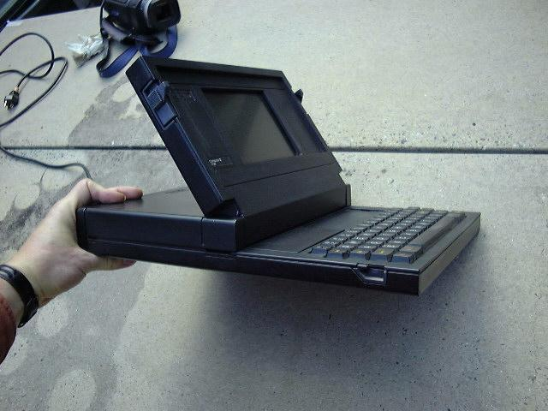

详解[回目录](http://www.techcn.com.cn/index.php?doc-view-140401.html" \l "section)

|  |
| --- |
| http://www.techcn.com.cn/uploads/201001/12623470675PktvilG.jpg GRiD onboard Space Shuttle "Discovery" mission STS-51G - June 1985.  source: [http://images.jsc.nasa.gov/](http://images.jsc.nasa.gov/luceneweb/caption_direct.jsp?photoId=STS51G-22-029) |

Designed to be the ultimate portable computer, the clamshell-style **GRiD Compass 1101** is the grand-daddy of all present-day laptop computers.   
  
The Compass is very high-tech, with its flat-black, die-cast magnesium-alloy case, and bright, sharp electroluminescent display (ELD). No other system packed so much speed and power in as small a case, and none had such a unique and large, easy-to-read screen, allowing full 80x24 text.   
  
Of course, all of these great features raised the price significantly. At $8150, the GRiD Compass 1101 was the most expensive personal computer you could buy.   
  
Originally developed for business executives, GRiDs were also used by the U.S. military 'in the field', and by NASA on the Space Shuttles during the 1980's and 90's. It's even been said that the US President's "nuclear football" at one time included a GRiD computer.   
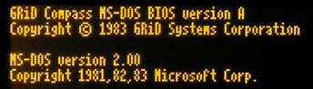Few, if any, non-IBM computers in 1982 ran MS-DOS, and the GRiD is no exception. Although MS-DOS compatibility was eventually added, the original GRiD 1101 ran only the GRiD-OS operating system - its design started in 1979, before MS-DOS or the IBM PC existed.   
  
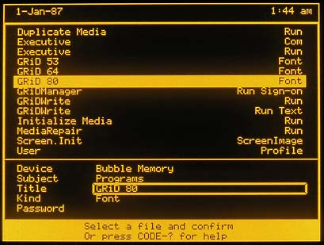But GRiD-OS is no slouch - the suite includes:

|  |  |
| --- | --- |
| -GRiDManager | -communication and utility functions |
| -GRiDPrint | -control format and appearance of text files |
| -GRiDWrite | -full-screen text editor |
| -GRiDPlan | -electronic worksheets |
| -GRiDFile | -database facilities |
| -GRiDPlot | -converts data to graphs |
| -GRiDBASIC | -programming language |

Controlled almost entirely my menus, GRiD-OS is a full-function, powerful operating system. It displays data by DEVICE, SUBJECT (folder), TITLE (file name), and KIND (file type). Files can be password protected if desired.   
  
Pressing the <CODE> key in conjuction with another, i.e. **<CODE> U**, activates commonly used functions, minimizing typing and speeding system operation.   
  
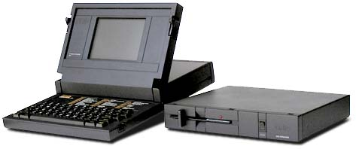While the Compass 1101 has no built-in floppy drive, its internal (non-removeable) 384K of bubble memory takes its place, and will hold your data indefinitely, even if all power is removed.   
  
An optional external 360K 5.25-inch floppy drive (model 2102 Portable Diskette Drive) was available, as well as an external 10 Meg hard drive/5.25-inch floppy drive combo (model 2101 Disk System).   
  
  
  
The GRiD Compass 1101 has three large bubble memory modules on the motherboard, as seen here to the right, for a total of 384K of data storage.   
  
Bubble memory was once the next-greatest thing in computer technology, being non-volatile, and having no moving parts. But bubble memory is serial, and thus the larger it is, the longer it takes to cycle your data through.   
  
Hard drive technology eventually eclipsed the capabilities of bubble memory, and 'bubbles' faded into oblivion.   
  
Still, until large non-volatile EEPROMs appeared, bubble memory was still used for another decade or so by the military, NASA, and applications which required small, reliable, and shock-resistant data recorders.   
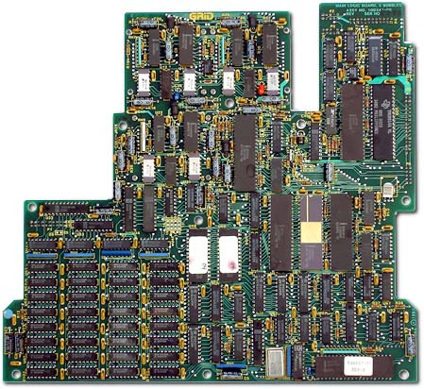  
  
The rechargeable battery for the built-in clock/calendar can be seen above with the 'bubbles'. It is glued down and soldered in, thus difficult to replace once it goes bad.   
  
The 'bubbles' are on the back of the motherboard, which is installed face-down inside the GRiD case.   
  
There is no room or sockets for any upgrades. All of the chips, including the memory and operating system ROMs, are soldered in and not easily replaced.   
  
  
The GRiD's built-in 300/1200 baud modem (a seperate card from the motherboard) and GRiDTerm software application allowed easy and convenient access to **GRiD Central** - an on-line file storage system which provided dial-up access to software libraries and remote data storage (up to 50K) for GRiD owners. The battery-backed clock/calendar helped keep track of the long-distance phone charges.   
  
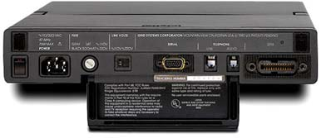   
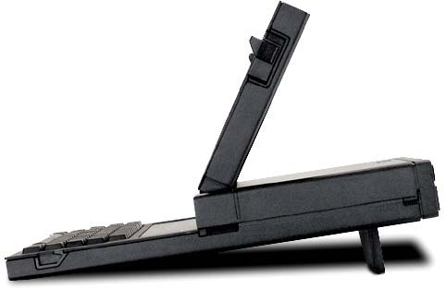  
The GRiD 1101 must be operated with the 'leg' in the down position, otherwise it stands a good chance of overheating. The 1101 runs very hot, almost too hot to touch.   
  
Not quite the ultimate portable, the 1101 does not run on batteries, it must be plugged into a 110/220 VAC wall outlet, although any standard computer power cord will work. It also, strangely enough, lacks a carrying handle. An official GRiD cloth carrying case came with the 1101, but it also lacks a carrying strap.

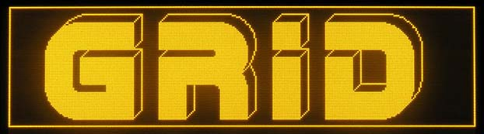

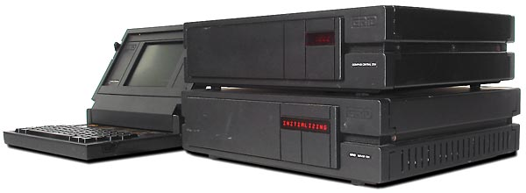

GRiD did not just sit on its laurels and wait for the rest of the world to catch up to it, they created many state-of-the-art peripherals and a networking system to link multiple GRiDs together.   
  
In addition to the previously-mentioned dial-up GRiD Central, a local server, the **GRiD Server 1701**, based on the Intel 80186 microprocessor, could link up to 32 GRiD Compass computers together as a personal version of GRiD central.   
  
Along with the GRiD **Compass Central 2701** external hard drive, Compass users can share data and peripherals and exchange messages directly with each other.

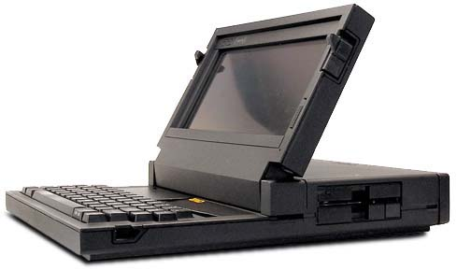  
While the Compass 1101 had no internal floppy drive, later systems did, such as the GRiDCase3 seen above.

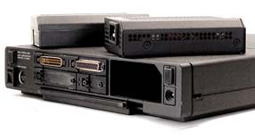  
  
The rear panel of the GRiDCase3 also shows the battery compartment. Most GRiD systems released after the 1101 can run on battery-power. The internal power supply is ejected and a battery-pack is installed in its place.   
  
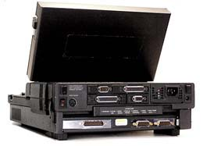  
  
The MS-DOS compatible GRiD 1530 from 1988 was the world's first battery powered Intel 80386DX Laptop. This one has attached to the bottom the optional 16-bit ISA compatible expansion bay, allowing the use of two full-size IBM compatible expansion cards.   
  
GRiD Systems Corp. was bought by Tandy (Radio Shack) in 1989, but GRiD computers continued to be produced.

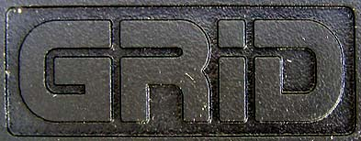  


谁是第一台笔记本电脑？[回目录](http://www.techcn.com.cn/index.php?doc-view-140401.html" \l "section)

1996年，美国《电脑杂志》提到康柏于1982年11月推出了一款手提电脑，重28磅（约合14公斤），这应该算是最早的笔记本电脑雏形。但IBM却拒绝接受这个说法，坚持认为它在1985年开发的一台名为PC Convertible的膝上电脑才是笔记本电脑真正意义上的“开山鼻祖”。   
  
美国人争吵不休，大洋那边的日本人也不乐意了。因为他们认定世界上第一台真正意义上的笔记本电脑是东芝公司的T1000，这款于1985年推出的产品采用Intel 8086 CPU，512KB RAM，并带有9英寸的单色显示屏，没有硬盘，可以运行MS-DOS操作系统。   
  
实际上，之所以会发生“谁制造了第一台笔记本电脑”的争执，关键在于日本人和美国人对笔记本电脑前身的理解不同。上世纪80年代初，IBM开发出个人PC后，人们梦想着开发出一种能够随身携带的PC产品。1983年，《国家电子》杂志首度提出了“手提电脑”的概念，后来这个概念又演变为“膝上型电脑”，当时包括苹果、IBM和康柏等公司都推出了这种产品。在美国人看来，正是“膝上型电脑”的发展催促了笔记本电脑的诞生。   
  
而在同时期的日本，东芝、松下和索尼等厂商则热衷于开发一种被称为“移动PC”的产品，“移动PC”基于IBM PS/2系统，使用外接电源。严格来讲，当时日本人所开发的“移动PC”更接近于今天的笔记本电脑。尤其是日本厂商在开发“移动PC”的过程中强调便携性，这与美国人设计那种笨重得需要扛起来才能移动的“膝上型电脑”形成鲜明对比。更为关键的是，正是在东芝T1000推出之后，笔记本电脑相关的各种新技术、新产品才纷纷出现，市场开始全面快速的发展。   
  
2001年，《美国计算机协会学报》在纪念PC诞生20周年的一篇报道中写了“1985年，东芝推出T1000，第一次给人们带来了‘笔记本电脑’的概念。”

日本人说：第一台笔记本电脑不是IBM的，更不是苹果的，是东芝的，TOSHIBA在1985年推出的的T1100型笔记型计算机（册页pdf版本，<http://resource.toshiba-europe.com/europe/computers/flyers/classics/t1000_E.pdf> ）。有点像现在的Nokia 9210C手机的放大版本。T-1000图片：<http://www.toshiba-europe.com/bv/computers/products/notebooks/t1000/images/pp_t1000.jpg>  
  
T-1000竟然也是施瓦辛格的魔鬼终结者中的角色？天啦。  
  
85年就算第一？是不是有点太晚了？  
  
而美国方面，康柏号称自己82年就有笔记本电脑了（<http://en.wikipedia.org/wiki/Compaq_Portable>）。不过这个太大的了，还不能跟现在的notebook相比，是叫便携式电脑而已。可以带走而已。键盘和显示器分离，显示器缩小到和主机放在一个箱子中而已。  
  
IBM则称自己在85年做出的第一台笔记本电脑是史上最早的笔记本电脑。美国人称为膝上型电脑。就是可以放在膝盖上用的电脑，起码显示器和键盘不要分离。  
（但也够大的了，有定像小时候玩过的苹果机<http://en.wikipedia.org/wiki/IBM_PC_Convertible>），不过因为是第一台和IBM兼容机，所以也常被人成为第一台商业用笔记本电脑。  
  
2001年，《美国计算机协会学报》在纪念PC诞生20周年的一篇报道中写了“1985年，东芝推出T1000，第一次给人们带来了‘笔记本电脑’的概念。”  
  
实际情况，笔记本电脑notebook的发展历史要早得多，很复杂。可看维姬百科的词条。  
<http://en.wikipedia.org/wiki/Notebook_computers#History>

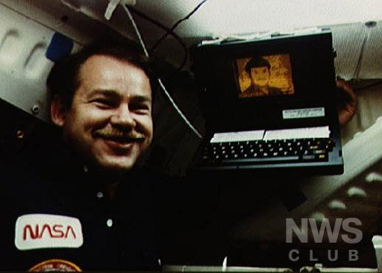

GRiD Compass 1101，这个比较有争议的笔记本电脑，85年都已经用在了发现号航天飞机上了。不过用的是自己的操作系统，也不能算商用的。而且这台笔记本键盘和显示屏铰接在一起，可以用电池。当时就上万美金价格，商用很难，但军方和NASA买了很多。  
<http://en.wikipedia.org/wiki/GRiD_Compass>  
  
苹果的第一台笔记本电脑则要晚多了。直到1989年9月它才第一次对应着IBM thinkpad做出了一个全白色的笔记本来，这可以看出，非黑即白在notebook市场的好处。(<http://en.wikipedia.org/wiki/Macintosh_Portable>)  
  
如果喜欢老计算机，你可以上这个老计算机博物馆网站去可能，一个blog形式的网站，不错。[http://www.old-computers.com](http://www.old-computers.com/)  
我个人的建议，作为中国PC业老大，全球PC市场老三，联想公司有必要建立一个计算机博物馆，提供全面的计算机发展历程，开放给中国用户，开放给全世界。我在博客中国时曾经跟联想谈过，可惜联想对做这个事情似乎兴趣不大。其实，总结历史，展望未来，跟投资奥运，是一样的效果。  
  
为何国外大PC厂商，能够不约而同地在80年代初想到了制作笔记本电脑，一定有其深层次的应用需求在推动。如果有心，联想一定可从过去的案例中，吸取经验。  
  
这个天涯问答很好，让人愿意来回到这样复杂的问题。我个人更觉得GRiD Compass 1101才是第一台真正的笔记本电脑。看下结构就知道，跟现在Thinkpad有区别么？  
  
只不过TOSHIBA和IBM都代表着各自的商业利益，他们乐得出来说第一了。看看wikipedia上汇总的notebook历史，我们就知道，他们还真只是某一个层面的上第一。

相关链接[回目录](http://www.techcn.com.cn/index.php?doc-view-140401.html" \l "section)

• [Official GRiD homepage (now GSCS)](http://www.grid.com/)

• [GRiD-UK](http://www.griduk.com/)

• [GRiD-FTP](http://www.ari-service.com/ftp/grid/) - (see [grid.txt](http://www.ari-service.com/ftp/GRID/grid.txt))

• [GRiDs in Space](http://www.netmagic.net/~clare/gis.html)

• ["Engineering the GRiD Compass"](http://video.google.com/videosearch?q=grid+compass+laptop) from Google Video

• [old-computers.com](http://www.old-computers.com/museum/computer.asp?c=900)

• [Wikipedia](http://en.wikipedia.org/wiki/GRiD_Compass)

• [Hrothgar's Cool Old Junk Page](http://pages.total.net/~hrothgar/museum/Compass/)

• • [GRiD UK](http://www.griduk.com/)

• [GRiD Compass 1101 at oldcomputers.net](http://oldcomputers.net/grid1101.html)

• [GRiD ftp](http://www.ari-service.com/ftp/grid/) - See [grid.txt](http://www.ari-service.com/ftp/GRID/grid.txt)

• [GRiDs in Space](http://www.netmagic.net/~clare/gis.html)

• [GRiD at old-computers.com](http://www.old-computers.com/museum/computer.asp?c=900)

• [GRiD at Hrothgar's Cool Old Junk Page](http://pages.total.net/~hrothgar/museum/Compass/)

• ["Engineering the GRiD Compass"](http://video.google.com/videosearch?q=grid+compass+laptop) at Google Video

参考文献[回目录](http://www.techcn.com.cn/index.php?doc-view-140401.html" \l "section)

http://en.wikipedia.org/wiki/GRiD_Compass  
http://oldcomputers.net/grid1101.html  
http://www.old-computers.com/museum/computer.asp?st=1&c=900